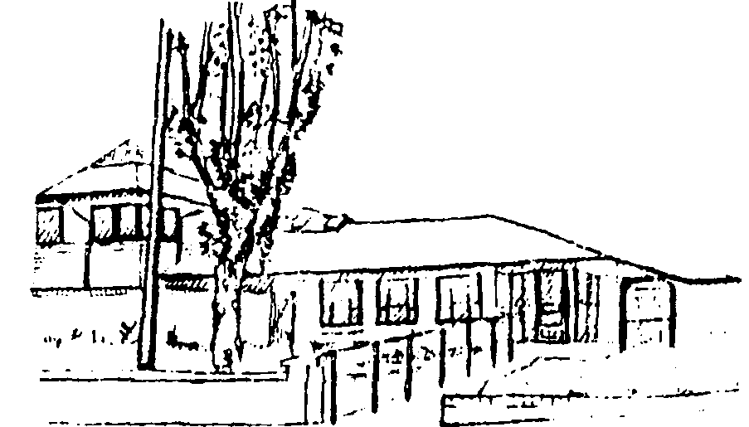

WESTERN ROAD

MEDICAL CENTRE

Dr N Leigh-Collyer, Dr S L Bond,

Dr A Dhairyawan, Dr S Awan, Dr Y Heerah,
Dr P Agarwal, Dr N Shamsudin

99 Western Road, Romford, Essex RM1 3LS
Tel: 01708 755300 Email: nelondonicb.westernroad@nhs.net
www.westernroad.co.uk.

AGREEMENT FOR A CARER TO HAVE ACCESS TO A PATIENT’S PERSONAL DETAILS and/or COPIES OF CORRESPONDENCE

Patient’s Name:  Date of Birth: | Carer’s Name:
Patient’s Address & Phone Number: | Carer’s Address & Phone Number:

To: Dr N Leigh-Collyer and Partners

I give permission for my Carer ……………………………. to have access to my medical records and personal details held by the Practice.

This permission relates to all / part of my record / specific condition only.
*(delete as appropriate).

Where the permission is restricted to part of the record only, please specify below the precise limits of this permission, and any areas of the record, which are excluded.
_______________________________________________________________________________________________________________________________________________________________________________________________________________________________________________________________________________________________
I understand that the doctor may override this authority at any time, and that this permission will remain in force until cancelled by me in writing.

I consent to my Carer receiving copies of all correspondence relating to my treatment, if necessary. I confirm that this has been explained to me by my GP and that the GP has sole discretion to withhold all or any copies.

Signed _______________________________ (Patient)

Date _________________________________

